Doping behaviors of N³⁻, In³⁺ and Sn⁴⁺ ions in TiO₂ and their applications in photocatalytic activity
Yanlong Yu†, Enjun Wang‡ and Yaan Cao†,*
†The MOE Key Laboratory of Weak Light Nonlinear Photonics, TEDA Applied Physics Institute and School of Physics, Nankai University, Tianjin 300457, China
‡Hefei Institutes of Physical Science, Chinese Academy of Sciences, Hefei 230031, China

Abstract
Nitrogen, indium and tin tri-doped TiO₂ photocatalyst was prepared by a simple sol-gel method It was revealed that tin was incorporated into TiO₂ crystal lattice in substitutional mode, while nitrogen and indium were present as surface species (NO_{x} and O-In-Cl_{x}). The resultant energy levels of doped tin, surface nitrogen and indium states are located inside the band gap. Hence tri-doping of nitrogen, indium and tin could greatly enhance the absorption in visible light region and inhibit the recombination of photogenerated charge carriers, resulting in an improved photocatalytic activity, compared with pure TiO₂, nitrogen doped TiO₂ and indium nitrogen co-doped TiO₂ for degradation of 4-chlorophenol under both visible and UV-light irradiation. This indicates that tri-doping TiO₂ simultaneously with three foreign elements is a feasible way to improve the photocatalytic activity of TiO₂.

Introduction
TiO₂ has been investigated extensively as photocatalysts for solar energy conversion and environmental applications, due to its high chemical stability and good photocatalytic performance.¹⁻⁵ However, the photocatalytic performance is still limited due to its large band gap (3.2eV for anatase), and its high recombination efficiency of photogenerated carriers. In order to improve the photocatalytic properties of TiO₂-based photocatalysts, doping with metal or non-metal elements, has become one of the most investigated systems and effective method to make the full use of solar light. For example, it has been confirmed that Sn⁴⁺ doping can improve the photocatalytic performance of TiO₂ under visible light irradiation by promoting the separation of photogenerated charge carriers and extending the absorption to visible region.¹³
Furthermore, the visible-light response and photocatalytic activity can be further enhanced for a photocatalyst with multi-dopants, such as (B, Ni)¹⁴, (In, B)¹⁵, (W,N)¹⁶ and (Ni, N)¹⁷, since the contribution comes from all the dopants. Our recent work has shown that modifying TiO₂ with nitrogen and indium is an effective method to improve the photocatalytic activity.¹⁸ The unique chemical species, O-In-Cl_{x} (x=1 or 2) is present on the surface of TiO₂ and the corresponding energy level is located at 0.3 eV below the conduction band of anatase, leading to an improvement of the visible light absorption and an efficient separation of charge carriers. However, the formation of surface species and doping behavior of the dopants are not explored up until now. Meanwhile, we seek to combine the advantages of Sn doped TiO₂ and In N co-modified TiO₂ with significant visible light response, and investigate the doping behavior of In N and Sn ions at the same time, to achieve a better understanding of TiO₂ based photocatalytic with significant photocatalytic activity.
In this paper, a new type of photocatalyst tri-doped with indium, nitrogen and tin is prepared via a simple sol-gel method. Tin is incorporated into the TiO₂ lattice in substitutional mode, while indium and nitrogen exist as surface species (such as NO and O-In-Cl_{x}). Moreover, as we expect, it exhibits much higher visible and UV –light photocatalytic activity than the other samples. The behaviors of the doping ions and mechanism of photocatalysis is also discussed in this contribution.

Experimental Details
  - Catalyst Preparation.
All chemicals used were of analytical grade and Milli-Q water (18.2 MΩ⋅cm) was used for all experiments. The tri-doped photocatalysts were prepared by the following steps. First, a certain volume of InCl₃ (0.6 mol L⁻¹)solution was mixed with 40 mL ethanol at room temperature to prepare solution A. Then 12 mL of Ti(OC₄H₉)₄ and 1 mL of concentrated HCl solution (12 mol L⁻¹) were added dropwise to solution A under vigorous stirring. After the mixture was stirred continuously for 15 min, 0.2 mL SnCl₄ and 3 mL ammonia were added. The white precipitation was formed immediately upon addition of ammonia, which was dried at 373K after aging at room temperature for 24 hours and then annealed at 723K in a muffle for 2.5 hours. Pure TiO₂, nitrogen doped TiO₂ (TiO₂-N), nitrogen and indium doped TiO₂ (TiO₂-N-In) are prepared by the same procedure, but with and without the addition of the corresponding reagent.
  - Characterization
The XRD patterns were acquired on a Rigaku D/max 2500 X-ray diffraction spectrometer (Cu Kα, λ=1.54056 Å). The average crystallite size was calculated according to the Scherrer formula (D = k λ/B cosθ). The BET surface areas of the samples were determined by nitrogen adsorption-desorption isotherm measurement at 77 K (Micromeritics Automatic Surface Area Analyzer Gemini 2360, Shimadzu). XPS measurements were carried out with an SECA Lab 220i-XL spectrometer by using an unmonochromated Al Kα (1486.6-eV) X-ray source. All the spectra were calibrated to the binding energy of the adventitious C1s peak at 284.8 eV. Raman spectra were taken on a Bruker RFS 100/S Raman spectrometer by using the 1064-nm line of a Nd:YAG laser as the excitation source. The diffuse reflectance UV-visible absorption spectra were collected on a UV-visible spectrometer (U-4100, Hitachi).
  - Evaluation of Photocatalytic Activity
The photocatalytic degradation of 4-chlorophenol was carried out in a 70 mL glass reactor with 10 mg amounts of catalysts suspended in 4-chlorophenol solution (5×10⁻⁵mol L⁻¹, 40 mL, pH = 5.38) under the visible light irradiation. A sunlamp (Philips HPA 400/30S, Belgium) was as light source, and a 400-nm filter was employed to remove ultraviolet light for obtainment of visible light. The reactor was perpendicular to the light beam and located 10 cm away from the light source. The 4-chlorophenol solution was continuously bubbled by O₂ gas at a flux of 5 mL min⁻¹ under magnetic stirring at 25±2 °C. Each two hours the residual concentration of 4-chlorophenol was measured by a UV-visible spectrometer (UV-1061PC, SHIMADZU) by using 4-aminoantipyrine as the chromogenic reagent. Prior to photocatalytic reactions, the suspension was magnetically stirred in the dark for 30 min, which was enough to reach the adsorption equilibrium of 4-chlorophenol.

Results
Photocatalytic activity
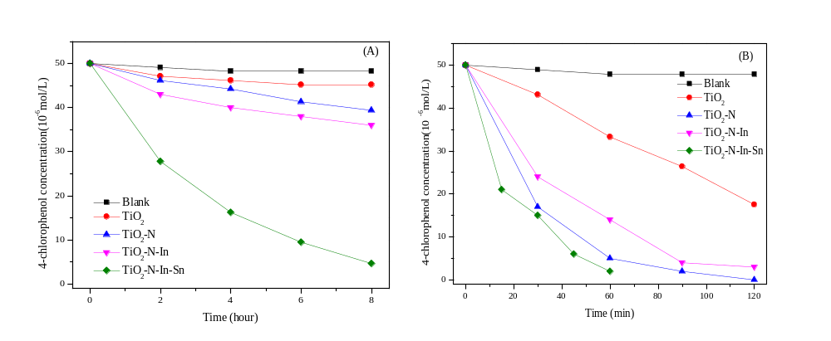Fig.1 Photocatalytic activity of TiO₂, TiO₂-N, TiO₂-N-In and TiO₂-N-In-Sn, (A) under visiblr light irradiation; (B) under UV-light irradiation.
The photodegradation of 4-CP was employed to evaluate the photocatalytic activity of TiO₂, TiO₂-N, TiO₂-N-In and TiO₂-N-In-Sn. The results are illustrated in Fig. 1, Table1 and Table 2, respectively. For all of the samples, the ln(c₀/c) values of 4-CP show a nearly linear relationshop with irradiation time, suggesting a pseudo-first-order reaction.
Under visible light irradiation (>400 nm) for 8 hours (shown in Fig.1A and Table 1), the 4-CP can hardly be degraded in the photolysis experiment. Only a little 4-CP has been decomposed in the presence of TiO₂ for some reason such as photolysis (Table 1). TiO₂-N and TiO₂-N-In exhibit better photocatalytic activity, while about 21.2% and 28.0% of 4-CP was decomposed for TiO₂-N and TiO₂-N-In, respectively. For TiO₂-N-In-Sn sample, almost 90.7% of 4-CP has been decomposed, whose photocatalytic activity (photodegradation rate and specific photocatalytic activity) is almost 4 and 3 times that for TiO₂-N and TiO₂-N-In, respectively. Under UV light irradiation (shown in Fig.1B and Table 2), the tri-doped TiO₂ sample still exhibits a much better photocatalytic performance than TiO₂, TiO₂-N and TiO₂-N-In samples. These results suggest that to dope Sn⁴⁺ ions into TiO₂-N-In system is an effective method to improve the photocatalytic performance significantly under both visible and UV light irradiation. The enhancement mechanismis discussed in the following sections.
Table 1. The photodegradation of 4-CP under visible light irradiation (λ>400nm).
Sample | Degradation  ratioª(Δc/c₀) | k ^{b}/min⁻¹ | t_{1/2}/min | Specific photocatalytic  activity /(mol•g⁻¹•h⁻¹)
Blank ^{c} | 0.035 | 7.42×10⁻⁵ | 9338.7 | —
TiO₂ | 0.097 | 2.11×10⁻⁴ | 3275.0 | 6.04×10⁻⁵
TiO₂-N | 0.212 | 4.97×10⁻⁴ | 1393.5 | 1.32×10⁻⁴
TiO₂-N-In | 0.280 | 6.84×10⁻⁴ | 1012.8 | 1.75×10⁻⁴
TiO₂-N-In-Sn | 0.907 | 4.95×10⁻³ | 140.0 | 5.67×10⁻⁴
ª After reaction for 8 h. ^{b} Apparent rate constant deduced from the linear fitting of ln(c₀/c) versus reaction time. ^{c} The blank was the photolysis of 4-CP.
Table 2. The photodegradation of 4-CP under UV light irradiation.
Sample | Degradation  ratioª(Δc/c₀) | k ^{b}/min⁻¹ | t_{1/2}/min | Specific photocatalytic  activity /(mol•g⁻¹•h⁻¹)
Blank ^{c} | 0.043 | 7.25×10⁻⁴ | 955.3 | —
TiO₂ | 0.335 | 6.79×10⁻³ | 102.1 | 1.67×10⁻³
TiO₂-N | 0.900 | 3.84×10⁻² | 18.1 | 4.50×10⁻³
TiO₂-N-In | 0.720 | 32.12×10⁻² | 32.7 | 3.60×10⁻³
TiO₂-N-In-Sn | 0.960 | 5.36×10⁻² | 12.9 | 4.80×10⁻⁴
ª After reaction for 1 h. ^{b} Apparent rate constant deduced from the linear fitting of ln(c₀/c) versus reaction time. ^{c} The blank was the photolysis of 4-CP

Discussion
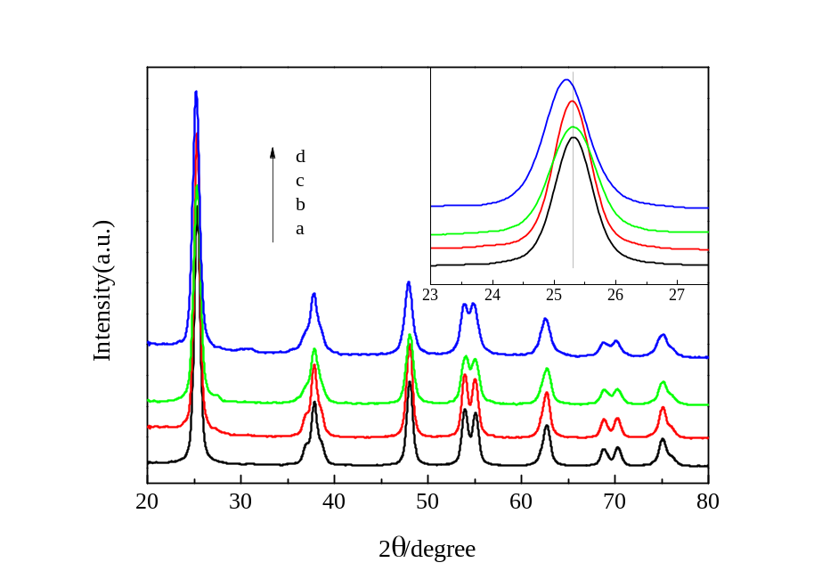
Fig. 2 XRD patterns of TiO₂ (a), TiO₂-N (b), TiO₂-N-In (c) and TiO₂-N-In-Sn (d). Inset is the enlarged XRD peaks of crystal plane (1 0 1).
The doping and modification mechanism is closely related to the crystallite structure, which has been studied by the XRD technique. Fig.2 shows the XRD patterns of TiO₂, TiO₂-N, TiO₂-N-In and TiO₂-N-In-Sn. It can be clearly seen that the majority of crystallite phase is anatase for all samples and no other characteristic diffraction peaks (such as rutile, In₂O₃ and SnO₂) are detected. The inset of Fig.2 is the enlarged XRD peaks of crystal plane (1 0 1) for all of the samples. Compared with the pure TiO₂ (curve a), no shift of the peak position is observable for TiO₂-N (curve b) and TiO₂-N-In (curve c), while the peak of TiO₂-N-In-Sn (curve d) shifts to lower diffraction angles. The diffraction peaks of crystal planes (1 0 1) and (2 0 0) in the curves are used to determine the lattice parameter and crystal size of all samples, which are summarized in Table 3. It is found that the cell volumes of TiO₂-N-In and TiO₂-N are almost the same as pure TiO₂, while the cell volume of TiO₂-N-In-Sn becomes much larger than that of pure TiO₂. The detailed mechanism is discussed in the following sections.
Table 3 Lattice parameters and crystal size of TiO₂, TiO₂-N, TiO₂-N-In and TiO₂-N-In-Sn.
Sample | cell parameters (Å) |  | cell volume  (Å³) | crystal size(nm) | S_{BET}  (m² g⁻¹)
Sample | a =b | c | cell volume  (Å³) | crystal size(nm) | S_{BET}  (m² g⁻¹)
TiO₂ | 3.784 | 9.501 | 136.03 | 12.9 | 68
TiO₂-N | 3.786 | 9.497 | 136.16 | 12.2 | 76
TiO₂-N-In | 3.785 | 9.489 | 135.97 | 10.2 | 82
TiO₂-N-In-Sn | 3.795 | 9.508 | 136.97 | 9.4 | 114
The doping mode is primarily determined by two factors: electronegativity and ionic radius of the doping ions. If the electronegativity and ionic radius of doping ions match those of the lattice ions in the oxide, the doping ions can substitute the lattice ions during the doping process.¹³ For the doping mode of nitrogen, since the ionic radius of nitrogen ion (171 pm) is much larger than that of the oxygen ion (140 pm)¹⁹, a dramatic change in lattice parameter and cell volume would be expected if nitrogen were substituted into the lattice. However, an obvious increase in lattice parameter and cell volume is not observed according to XRD results. The doping of nitrogen into TiO₂ lattice in the substitutional mode could be excluded. Hence, it is proposed that nitrogen exist as surface species.
It is documented that there are usually two kinds of doping modes, interstitial and substitutional, for doped metal ions in oxides.¹³ In the case of interstitial mode, the ionic radius of dopant should be smaller than that of the lattice metal ions and the oxide lattice spacing, allowing the doping ions to enter into the crystal cell of the oxide. As the ionic radiuses of both In³⁺ ion (1.7, 81pm)²⁰ and Sn⁴⁺ ions (1.8, 69pm)¹⁹ are larger than that of lattice Ti⁴⁺ ion (1.5, 53pm)¹³, it is almost impossible for In³⁺ and Sn⁴⁺ ions to incorporate into the crystal cell of TiO₂ through the interstitial mode. In the case of substitutional mode, the doping metal ions will replace the lattice metal ions and thus occupy the positions of the lattice metal ions in the oxide. If the ionic radius of the doping ions is larger than that of lattice ions, the lattice parameters and cell volume of the doped oxide should becomelarger than those of the pure oxide. As a result, the positions of all of the diffraction peaks in XRD patterns should shift to lower diffraction angles. No shift of the peaks was observed in the XRD patterns of TiO₂-N-In compared with TiO₂-N (shown in the inset of Fig.2), meanwhile the lattice parameters and cell volume of TiO₂-N-In were almost the same as those of TiO₂-N (Table 3). Therefore, the doping of In³⁺ ions into TiO₂ through the substitutional mode can also be excluded. However, an obvious increase in lattice parameter and cell volume is detected for TiO₂-N-In-Sn, compared with TiO₂-N-In. Therefore, based on the results of XRD, it is reasonable to deduce that tin can incorporate into the TiO₂ matrix in substitutional mode, while both indium and nitrogen exists as surface species, which would be further confirmed by XPS results.
In addition, it is noted that the crystal size decreases with the increase of doping elements (Table 1), indicating doping nitrogen, indium and tin ions can inhibit the grain growth of TiO₂ particles remarkably. The BET specific surface area ranks in the order of TiO₂<TiO₂-N< TiO₂-N-In< TiO₂-N-In-Sn (Table 2), which agrees with the trend for the change in crystal size of the samples.

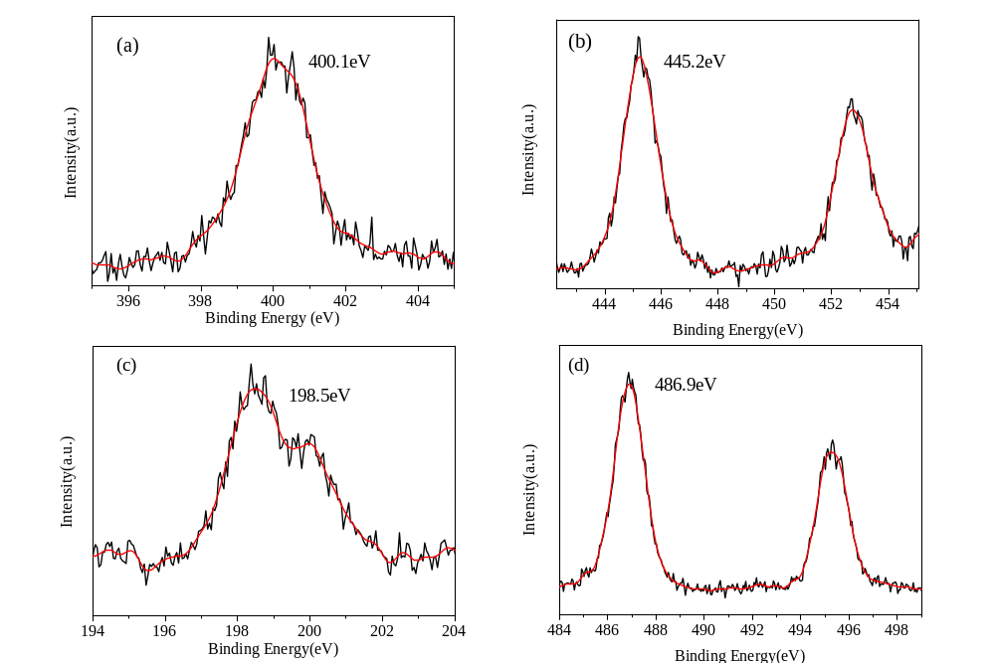
Fig.3 XPS spectra of N1s (a), In3d (b), Cl2p (c) and Sn3d (d) for TiO₂-N-In-Sn sample.
XPS measurements are used to investigate the chemical states of N, In and Sn in TiO₂-N-In-Sn sample. Except for the signals from nitrogen, indium and tin introduced during the preparation of TiO₂, only the signals from Ti, O, Cl and adventitious C was detected in the XPS spectra. As shown in Fig.3a, the N1s peak of TiO₂-N-In-Sn whose broad peak centers at about 400.1eV is a typical feature for N doped TiO₂ which has been observed by many researchers. This peak’s position is much higher than the typical binding energy of 396.9 eV in TiN²³, indicating that the N atoms interact strongly with O atoms.²⁴ Therefore the binding energy of 400.1eV could be attributed to the oxidized nitrogen similar to NO_{x} species, meaning that Ti-N-O linkage possibly formed on the surface of TiO₂.²⁵
Fig.3b and Fig.3c shows the In 3d and Cl 2p spectra of a typical O-In-Cl_{x} (x=1 or 2) species formed on the surface of TiO₂ which has been demonstrated by our previous work. The binding energy of In3d_{5/2} (445.2eV) locates between those of In3d_{5/2} in In₂O₃ (444.6eV)²⁷ and InCl₃ (446.0eV)²⁸. For the Cl2p XPS spectra of TiO₂-N-In-Sn (Fig.3c), the binding energy of Cl2p_{3/2} locates between TiCl₄ and InCl₃. These results suggest that the doped In³⁺ ions may link with the unsaturated O²⁻ and Cl⁻ ions simultaneously, resulting in the formation of an O-In-Cl_{x} (x=1 or 2) structure on the surface of TiO₂.
Fig.3d presents the Sn3d spectra of TiO₂-N-In-Sn and the peak around 486.9eV is ascribed to Sn3d_{5/2}, which falls between that for SnO₂ (487.8eV)²⁹ and metallic Sn (485.0eV)³⁰ and arises from the doping Sn⁴⁺ ions that substitute lattice Ti⁴⁺ ions. Since the electronegativity of Sn (1.8) is larger than that of Ti (1.5), the electron density of Sn atoms in Sn-O-Sn would be higher than that in Sn-O-Ti, which exactly explains why the binding energy of doped Sn⁴⁺ ions in substitutional mode is lower than that for SnO₂.Therefore, according to XRD and XPS results, both the introduced indium and nitrogen exist as surface species (O-In-Cl_{x} and NO_{x} species), while tin incorporates into TiO₂ lattice in substitutional mode. The doping behaviors of nitrogen, indium and tin would be discussed in the following sections.
Scheme 1. Proposed mechanism for the formation of surface species.
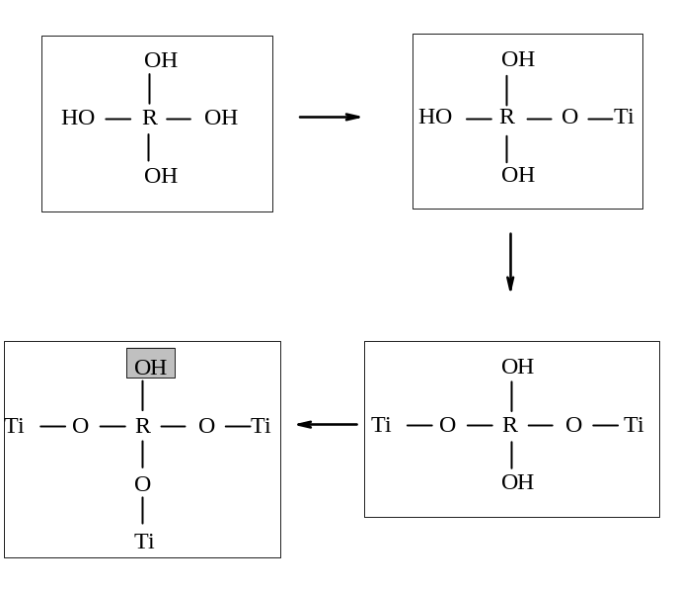
The reason why Sn is doped into TiO₂ lattice and In exists as surface species could be explained by the following mechanism. During the gelation process for pure TiO₂, one Ti ion which links with six hydroxyls would dehydrate and condense with another Ti ion to form Ti-O-Ti structure.³¹⁻³³ After the introduction of the dopants, the doped ions (R) that usually links with four hydroxyls would also condense with the Ti-OH the by the following equation:
Ti-OH + HO-R → Ti -O- R + H₂O
The condensation ability of hydroxyl is closely related to the ionic potential of the doped ions (R). In the case of In doped TiO₂, it is noticed that the ionic potential of In³⁺ (0.037) is much smaller than Ti⁴⁺ (0.059). Therefore the condensation ability of hydroxyl for the doped In ions would be weakened after the formation of Ti-O-In structure. If the hydroxyl of In³⁺ condenses with more than one hydroxyl of Ti⁴⁺, the remaining hydroxyl may reduce or even lose the ability to condense with other Ti-OH. It would be difficult for the remaining In-OH to condense with other Ti-OH, as shown in Scheme 1. However, as the ionic potential for Sn⁴⁺ (0.056) is almost the same as that for Ti⁴⁺ (0.059), the condensation ability for Sn-OH is almost unchanged after it condenses with Ti-OH. Thus, In³⁺ exist as O-In-Cl_{x} species on the surface of TiO₂ while Sn⁴⁺ ions were doped into TiO₂ lattice in substitutional mode. Similarly, the formation of surface NO_{x} species could also be explained by the same mechanism.
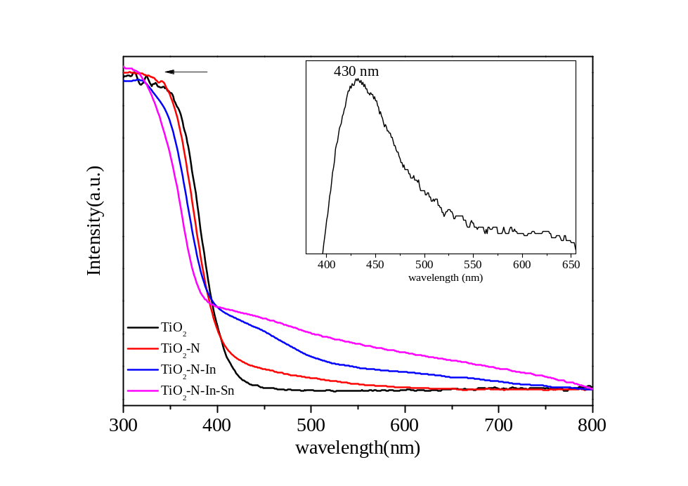
Fig.4 Diffuse reflectance UV-vis spectra of pure TiO₂, TiO₂-N, TiO₂-N-In and TiO₂-N-In-Sn. Inset gives the differenve DRS spectra of TiO₂-Sn.
The band structure and doping energy level are closely related to the process of photogenerated carriers and photocatalytic activity. Fig.4 gives the UV-vis DRS absorption spectra of TiO₂, TiO₂-N, TiO₂-N-In and TiO₂-N-In-Sn. Pure TiO₂ exhibits only a strong absorption in the UV region which is attributed to the band-to-band transition.¹⁶ The absorption edge is about 410nm, corresponding to a band gap of 3.02eV. Compared with the pure TiO₂, the spectra of TiO₂-N presents a small hump at between 400nm and 600 nm tailing the visible light region, which is a typical absorption feature of nitrogen doped TiO₂ and arises from the electron transition from surface state of NO_{x} species to the conduction band of TiO₂. A blue-shift is found for TiO₂-N compared with pure TiO₂ and the absorption edge shift to 408nm, corresponding to a widened band gap of 3.04eV. The visible light absorption becomes stronger after indium is introduced into the TiO₂-N system. The strong visible light absorption of TiO₂-N-In is ascribed to the common effects of both nitrogen and indium modification. It is clearly seen that the absorption edge for TiO₂-N-In shifts to 405nm and the band gap is estimated to be 3.06eV. The TiO₂-N-In-Sn sample presents the strongest absorption in the visible region among all the samples, as the contribution comes from substitutional doped tin and the surface species of indium and nitrogen. In addition, an obvious blue shift by 6 nm is found for tri-doped sample and corresponding band gap increases to 3.10eV, compared with TiO₂-N-In. The blue-shift for these samples is caused by the quantum size effect, indicating that doping one or more of N, In and Sn elements into TiO₂ could inhibit the grain growth of nanoparticles effectively, which is in good agreement with the XRD results. These results suggest that the introducing tin into TiO₂-N-In system is an efficient method to make photocatalysts more sensitive to visible light.
It has been demonstrated by our previous work that the energy level of NO_{x} and of O-In-Cl_{x} (x=1 or 2) surface species locates at 0.25eV³⁶ above the valence band of TiO₂ and 0.3 eV below the conduction band of TiO₂, respectively. To locate the position of doped Sn⁴⁺ energy level, the difference DRS spectra was obtained by subtracting the absorbance spectra of pure TiO₂ from tin doped TiO₂, as shown in the inset of Fig.4. The position of the absorption maximum is around 430nm, corresponding to an energy level gap of about 2.9 eV. The surface state energy level contributed by the doped Sn⁴⁺ ions is likely to locate at about 0.2 eV below the conduction band of TiO₂, which would facilitate the electron transition from conduction band of TiO₂ to O-In-Cl_{x} surface species. This would be further supported by the laser photoluminescence spectral measurements in the following section.
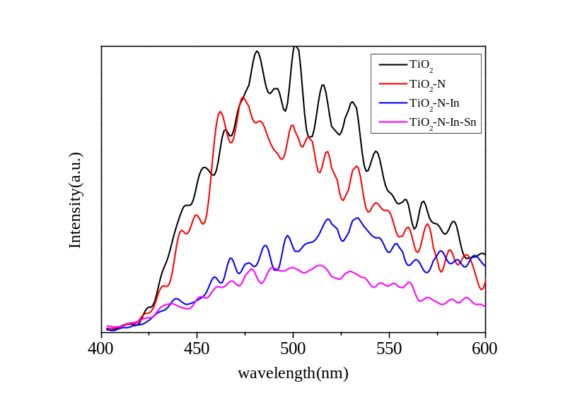
Fig.5 Photoluminescence spectra of pure TiO₂, TiO₂-N, TiO₂-N-In and TiO₂-N-In-Sn
The photocatalytic activity is closely related to the separation and recombination behavior of the photogenerated electrons and holes. The photogenerated electrons first fall into the defects from the CB via a nonradiative process and then recombine with the holes in VB to give rise to fluorescence emission. Hence, the photoluminescence (PL) emission spectra is a helpful method to understand the behavior of photogenerated electrons and holes in the semiconductor.³⁵ Fig.5 shows the PL spectra of TiO₂, TiO₂-N, TiO₂-N-In and TiO₂-N-In-Sn. Two peaks at around 480 nm and 525 nm are observed for the pure TiO₂ sample, which could be attributed to the transition from the oxygen vacancies with two trapped electrons and one trapped electron to the valence band, located at 0.51 eV and 0.82 eV below the conduction band respectively.³⁹⁻⁴² The emission intensity is slightly weakened for TiO₂-N and further quenched significantly for TiO₂-N-In. A lower PL intensity of TiO₂-N is due to the capture of photogenarated holes by surface NO_{x} species. The effective quenching of PL for TiO₂-N-In is owing to the formation of surface state energy level of O-In-Cl_{x} (x=1 or 2) which would trap the photogenerated electrons. As we expect, the TiO₂-N-In-Sn photocatalyst shows the lowest PL intensity among all four samples. As the doping energy level of Sn⁴⁺ ions locate at 0.2 eV below the conduction band in TiO₂-N-In-Sn sample, which is higher than those of oxygen vacancies (0.51ev and 0.82eV below the conduction), the photogenerated electrons in the conduction band are inclined to move from the conduction band to the doping energy level of Sn⁴⁺ ions, rather than to the oxygen vacancies. Furthermore, the photogenerated electrons in the Sn⁴⁺ doping energy level would also transfer to the surface O-In-Cl_{x} surface species. As a result, the emission intensity originated from the transition from oxygen vacancies to the valence band decreases significantly after doping of Sn⁴⁺ ions. Therefore, the efficient separation of photogenerated holes and electrons for TiO₂-N-In-Sn is contributed from both the doped tin and surface species (surface NO_{x} species and O-In-Cl_{x} species, x=1 or 2), resulting in a much suppressed recombination of photogenerated charge carriers.
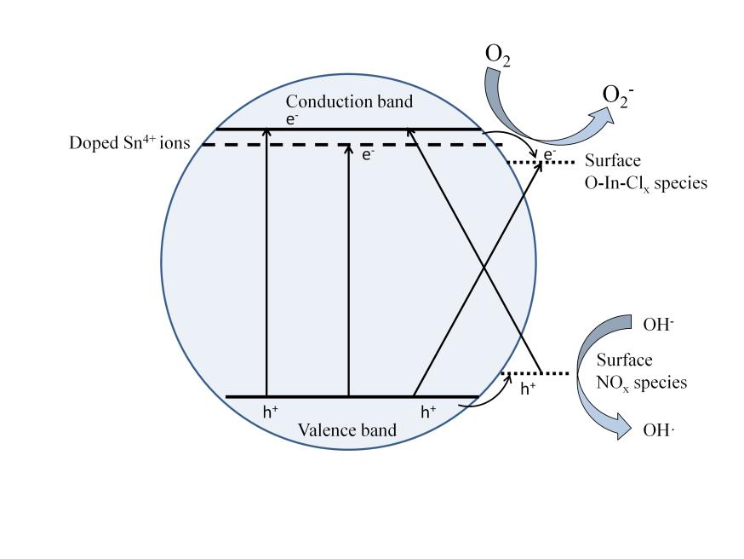
Fig.6 Schematic diagram of photocatalytic mechanism for nitrogen and indium co-modified TiO₂.
Based on the aforementioned results, the reason that TiO₂-N-In-Sn exhibits the best photocatalytic activity on degradation of 4-CP under both visible and UV light irradiation could be explained using the scheme shown in Fig.6. In the case of visible light, pure TiO₂ can hardly be excited due to its large band gap, which leads to a poor visible-light photocatalytic performance on photodegradation of 4-CP. After doping with nitrogen, electrons can be excited directly from the surface state energy level of NO_{x} surface species to the conduction band, as the surface state energy level of NO_{x} species locate at 0.25eV above the valence band of TiO₂. Moreover, the NO_{x} surface species can also act as hole trapping centers, inhibiting the recombination of photogenerated charge carriers. Thus, the photocatalytic activity of TiO₂-N is improved under visible light irradiation, compared with pure TiO₂.
For TiO₂-N-In, the formation of NO_{x} species and O-In-Cl_{x} species are responsible for the broad absorption in visible light region. Under visible light irradiation, electrons can be excited simultaneously from the surface state energy level of NO_{x} species to the conduction band of TiO₂, or from the valence band of TiO₂ to the surface state energy level of O-In-Cl_{x} species. Meanwhile, the photogenerated electrons in the conduction band would fall into the energy levels of O-In-Cl_{x} species, and the holes in the valence band migrate to the energy levels of NO_{x} species. As a result, the photogenerated electrons and holes can be separated efficiently and more charge carriers would take part in the photocatalytic reaction, resulting in a better photocatalytic activity than TiO₂.
For TiO₂-N-In-Sn sample, besides the contribution of surface species (NO_{x} and O-In-Cl_{x} species), electrons can also be excited from valence band to Sn⁴⁺ doping energy level, which causes the further absorption in visible region and increase the total amount of photogenerated electrons and holes significantly. Electrons at the conduction band could also fall into the doping energy level of Sn⁴⁺, resulting in a more efficient separation of photogenerated charge carriers. As a result, more photogenerated electrons and holes will contribute to the photocatalytic process, resulting in the best photocatalytic activity among all samples.
In the case of UV light, TiO₂-N-In-Sn sample still presents a much better photocatalytic performance than the other photocatalysts. Besides the efficient separation of photogenerated charge carriers, the large band gap caused by the quantum size effect also contribute to the photocatalytic performance, as the enlarged band gap of TiO₂ usually accompanies with enhanced redox ability. Furthermore, the increased BET surface areas for TiO₂-N-In-Sn is also in favor of the photocatalytic activity.

Conclusion
In summary, for the purpose of utilizing solar light efficiently, a new type of TiO₂-based photocatalyst (TiO₂-N-In-Sn) has been successfully prepared by doping TiO₂ with nitrogen, indium and tin via a sol-gel method. The TiO₂-N-In-Sn sample exhibits a much higher photocatalytic activity than pure TiO₂, TiO₂-N and TiO₂-N-In under both UV and visible light, which contributes from the doped tin and surface species (NO_{x} and O-In-Cl_{x} species), implying that introducing Sn into modified TiO₂ with In and N is an effective method to improve the photocatalytic activity of TiO₂. The doping behavior of tin and formation mechanism of surface nitrogen and indium species is also revealed in this work. It is expected that ongoing research on such catalysts would be helpful for the development of TiO₂-based visible-light driven photocatalysts.

Acknowledgements
This work is supported by the National natural Science Foundation of China (Nos 51072082, 21173121, 51302269 and 51372120).

References
1. Fujishima, A.; Honda, K. Photolysis-decomposition of water at the surface of an irradiated semiconductor. Nature 1972, 238, 37-38.
2. Khaselev, O.; Turner, J. A. A monolithic photovoltaic-photoelectrochemical device for hydrogen production via water splitting. Science 1998, 280, 425-427.
3. Khan, S. U.; Al-Shahry, M.; Ingler, W. B. Efficient photochemical water splitting by a chemically modified n-TiO2. Science 2002, 297, 2243-2245.
4. Hoffmann, M. R.; Martin, S. T.; Choi, W.; Bahnemann, D. W. Environmental applications of semiconductor photocatalysis. Chem. Rev. 1995, 95, 69-96.
5. Hagfeldt, A.; Graetzel, M. Light-induced redox reactions in nanocrystalline systems. Chem. Rev. 1995, 95, 49-68.
6. Li, X.; Li, F. Study of Au/Au3+-TiO2 photocatalysts toward visible photooxidation for water and wastewater treatment. Environ. Sci. Technol. 2001, 35, 2381-2387.
7. Asahi, R.; Morikawa, T.; Ohwaki, T.; Aoki, K.; Taga, Y. Visible-light photocatalysis in nitrogen-doped titanium oxides. Science 2001, 293, 269-71.
8. Bowker, M.; James, D.; Stone, P.; Bennett, R.; Perkins, N.; Millard, L.; Greaves, J.; Dickinson, A. Catalysis at the metal-support interface: exemplified by the photocatalytic reforming of methanol on Pd/TiO< sub> 2</sub>. J. Catal. 2003, 217, 427-433.
9. Wu, P. G.; Ma, C. H.; Shang, J. K. Effects of nitrogen doping on optical properties of TiO2 thin films. Appl. Phys. A 2004, 81, 1411-1417.
10. Sreethawong, T.; Yoshikawa, S. Comparative investigation on photocatalytic hydrogen evolution over Cu-, Pd-, and Au-loaded mesoporous TiO2 photocatalysts. Catal. Commun. 2005, 6, 661-668.
11. Cao, Y.; He, T.; Zhao, L.; Wang, E.; Yang, W.; Cao, Y. Structure and phase transition behavior of Sn⁴⁺-doped TiO₂ nanoparticles. J. Phys. Chem. C 2009, 113, 18121-18124.
12. Yuan, J.; Wang, E.; chen, Y.; Yang, W.; Yao, J.; Cao, Y. Doping mode, band structure and photocatalytic mechanism of B-N-codoped TiO₂. Appl. Surf. Sci. 2011, 257, 7355-7342.
13. Cao, Y.; Yang, W.; Zhang, W.; Liu, G.; Yue, P. Improved photocatalytic activity of Sn4+ doped TiO2 nanoparticulate films prepared by plasma-enhanced chemical vapor deposition. New J. Chem. 2004, 28, 218-222.
14. Zhao, W.; Ma, W.; Chen, C.; Zhao, J.; Shuai, Z. Efficient degradation of toxic organic pollutants with Ni2O3/TiO2-x B x under visible irradiation. J. Am. Chem. Soc. 2004, 126, 4782-4783.
15. Yu, Y.; Wang, E.; Yuan, J.; Cao, Y. Enhanced photocatalytic activity of titania with unique surface indium and boron species. Appl. Surf. Sci. 2013, 273, 638-644.
16. Gao, B.; Ma, Y.; Cao, Y.; Yang, W.; Yao, J. Great enhancement of photocatalytic activity of nitrogen-doped titania by coupling with tungsten oxide. J. Phys. Chem. B 2006, 110, 14391-14397.
17. Cao, Y.; Yu, Y.; Zhang, P.; Zhang, L.; He, T.; Cao, Y. An Enhanced Visible-Light Photocatalytic Activity of TiO< sub> 2</sub> by Nitrogen and Nickel-Chlorine Modification. Separation and Purification Technology 2012.
18. Wang, E.; Zhang, P.; Chen, Y.; Liu, Z.; He, T.; Cao, Y. Improved visible-light photocatalytic activity of titania activated by nitrogen and indium modification. J. Mater. Chem. 2012.
19. Wang, E.; He, T.; Zhao, L.; Chen, Y.; Cao, Y. Improved visible light photocatalytic activity of titania doped with tin and nitrogen. J. Mater. Chem. 2010, 21, 144-150.
20. Okushita, H.; Shimidzu, T. Selective and active transport of In3+ through N-nitroso-Np-octadecylphenylhydroxylamine ammonium salt impregnated membrane. Bull. Chem. Soc. Jpn. 1990, 63, 920-925.
21. Cong, Y.; Zhang, J.; Chen, F.; Anpo, M. Synthesis and characterization of nitrogen-doped TiO2 nanophotocatalyst with high visible light activity. J. Phys. Chem. C 2007, 111, 6976-6982.
22. Di Valentin, C.; Pacchioni, G.; Selloni, A.; Livraghi, S.; Giamello, E. Characterization of paramagnetic species in N-doped TiO2 powders by EPR spectroscopy and DFT calculations. J. Phys. Chem. B 2005, 109, 11414-11419.
23. Saha, N. C.; Tompkins, H. G. Titanium nitride oxidation chemistry: An x‐ray photoelectron spectroscopy study. J. Appl. Phys. 1992, 72, 3072-3079.
24. Sathish, M.; Viswanathan, B.; Viswanath, R.; Gopinath, C. S. Synthesis, characterization, electronic structure, and photocatalytic activity of nitrogen-doped TiO2 nanocatalyst. Chem. Mater. 2005, 17, 6349-6353.
25. Gopinath, C. S. Comment on “photoelectron spectroscopic investigation of nitrogen-doped titania nanoparticles”. J. Phys. Chem. B 2006, 110, 7079-7080.
26. Wang, E.; Yang, W.; Cao, Y. Unique surface chemical species on indium doped TiO₂ and their effect on the visible light photocatalytic activity. J. Phys. Chem. C 2009, 113, 20912-20917.
27. Reddy, B. M.; Chowdhury, B.; Smirniotis, P. G. An XPS study of La< sub> 2</sub> O< sub> 3</sub> and In< sub> 2</sub> O< sub> 3</sub> influence on the physicochemical properties of MoO< sub> 3</sub>/TiO< sub> 2</sub> catalysts. Applied Catalysis A: General 2001, 219, 53-60.
28. Freeland, B. H.; Habeeb, J. J.; Tuck, D. G. Coordination compounds of indium. Part XXXIII. X-Ray photoelectron spectroscopy of neutral and anionic indium halide species. Can. J. Chem. 1977, 55, 1527-1532.
29. Cao, X.; Cao, L.; Yao, W.; Ye, X. Structural Characterization of Pd‐doped SnO2 Thin Films Using XPS. Surf. Interface Anal. 1996, 24, 662-666.
30. Taylor, J. A.; Lancaster, G. M.; Rabalais, J. W. Chemical reactions of N< sub> 2</sub>< sup>+</sup> ion beams with group IV elements and their oxides. J. Electron Spectrosc. Relat. Phenom. 1978, 13, 435-444.
31. Livage, J.; Henry, M.; Sanchez, C. Sol-gel chemistry of transition metal oxides. Prog. Solid State Chem. 1988, 18, 259-341.
32. Chemseddine, A.; Moritz, T. Nanostructuring titania: control over nanocrystal structure, size, shape, and organization. Eur. J. Inorg. Chem. 1999, 1999, 235-245.
33. Henry, M.; Jolivet, J. P.; Livage, J. Aqueous chemistry of metal cations: hydrolysis, condensation and complexation. In Chemistry, Spectroscopy and Applications of Sol-Gel Glasses, Springer: 1992; pp 153-206.
34. Lindgren, T.; Mwabora, J. M.; Avendaño, E.; Jonsson, J.; Hoel, A.; Granqvist, C.-G.; Lindquist, S.-E. Photoelectrochemical and optical properties of nitrogen doped titanium dioxide films prepared by reactive DC magnetron sputtering. J. Phys. Chem. B 2003, 107, 5709-5716.
35. Sun, H.; Bai, Y.; Jin, W.; Xu, N. Visible-light-driven TiO< sub> 2</sub> catalysts doped with low-concentration nitrogen species. Sol. Energy Mater. Sol. Cells 2008, 92, 76-83.
36. Cao, Y.; Yu, Y.; Zhang, P.; Zhang, L.; He, T.; Cao, Y. An enhanced visible-light photocatalytic activity of TiO2 by nitrogen and nickel–chlorine modification. Sep. Purif. Technol. 2013, 104, 256-262.
37. In, S.; Orlov, A.; Berg, R.; García, F.; Pedrosa-Jimenez, S.; Tikhov, M. S.; Wright, D. S.; Lambert, R. M. Effective visible light-activated B-doped and B, N-codoped TiO2 photocatalysts. J. Am. Chem. Soc. 2007, 129, 13790-13791.
38. Hashmi, A. S. K.; Rudolph, M. Gold catalysis in total synthesis. Chem. Soc. Rev. 2008, 37, 1766-1775.
39. Di Li; Haneda, H.; Hishita, S.; Ohashi, N. Visible-light-driven NF-codoped TiO2 photocatalysts. 2. Optical characterization, photocatalysis, and potential application to air purification. Chem. Mater. 2005, 17, 2596-2602.
40. Serpone, N.; Lawless, D.; Khairutdinov, R.; Pelizzetti, E. Subnanosecond relaxation dynamics in TiO2 colloidal sols (particle sizes Rp= 1.0-13.4 nm). Relevance to heterogeneous photocatalysis. J. Phys. Chem. 1995, 99, 16655-16661.
41. Jimmy, C. Y.; Ho, W.; Yu, J.; Hark, S.; Iu, K. Effects of trifluoroacetic acid modification on the surface microstructures and photocatalytic activity of mesoporous TiO2 thin films. Langmuir 2003, 19, 3889-3896.
42. Saraf, L.; Patil, S.; Ogale, S.; Sainkar, S.; Kshirsager, S. Synthesis of nanophase TiO 2 by ion beam sputtering and cold condensation technique. International Journal of Modern Physics B 1998, 12, 2635-2647.

